Project Design Phase-II
Technology Stack (Architecture & Stack)

Date | 03 October 2026
Team ID
  SWTID-2026-8726
Project Name
  Auto Ticket Classification using FLOW
  DESIGNER
Maximum Marks | 4 Marks

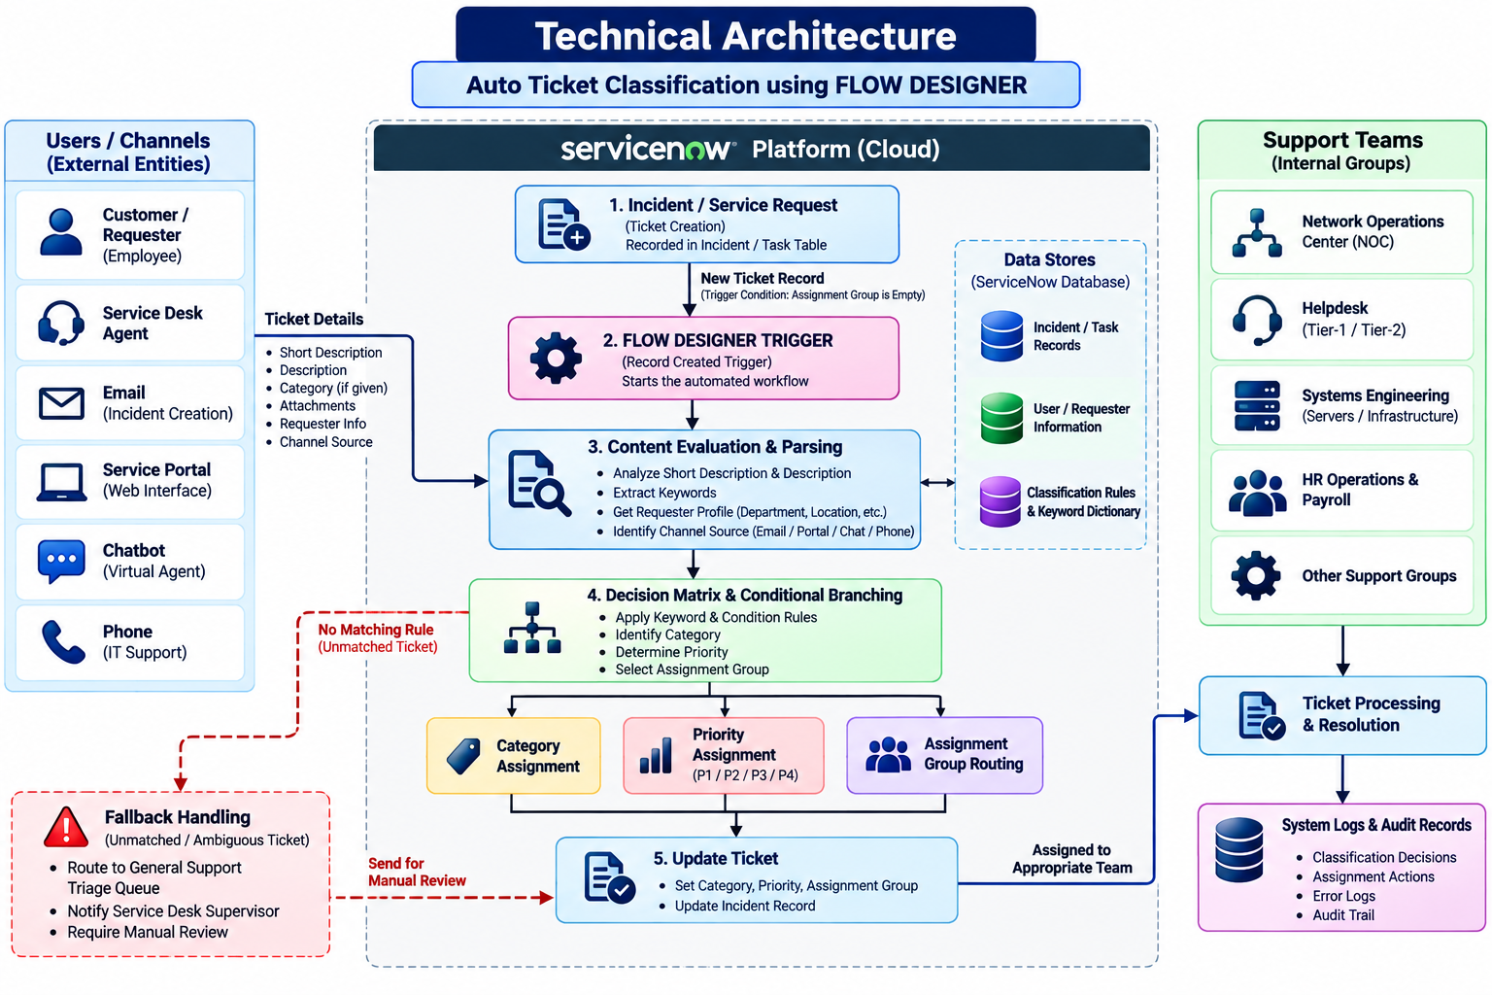
Technical Architecture:

Table-1 : Components & Technologies:
S.No | Component | Description | Technology
- 1 | User Interface | Interface through which users submit incidents or service requests | ServiceNow Service Desk Portal / Web Interface
- 2 | Ticket Management | Creates and stores incoming incident/service request records | ServiceNow Incident / Task Table
- 3 | Workflow Automation | Automatically starts and controls the ticket-classification workflow | ServiceNow Flow Designer
- 4 | Content Evaluation | Evaluates ticket description, keywords, requester information and channel source | Flow Designer Data Processing / Flow Logic
- 5 | Classification Engine | Identifies ticket category using predefined conditions and keywords | Flow Designer If-Else / Switch Logic
- 6 | Priority Assignment | Determines appropriate P1–P4 priority according to configured conditions | Flow Designer Conditional Rules
- 7 | Assignment Routing | Automatically routes tickets to the appropriate support group | Flow Designer Update Record / Assignment Group Logic
- 8 | User Information | Provides requester department, location and other profile information | ServiceNow User / Requester Records
- 9 | Rule / Keyword Data | Stores classification keywords, conditions and routing mappings | ServiceNow Configuration / Flow Conditions
- 10 | Exception Handling | Handles unmatched, ambiguous and conflicting tickets | General Support Triage Queue / Flow Fallback Logic
- 11 | Logging & Audit | Records classification decisions, transformations and assignment actions | ServiceNow System Logs / Audit Records
The current project uses rule/keyword-driven Flow Designer automation. Machine Learning, sentiment analysis, multilingual support and dynamic load balancing are listed as future enhancements rather than current components.

Table-2: Application Characteristics:
S.No | Characteristics | Description | Technology
- 1 | Open-Source Frameworks | No separate open-source application framework is specified in the current implementation. | ServiceNow Flow Designer
- 2 | Security | Workflow execution and ticket data access are controlled through the ServiceNow platform and configured application permissions. | ServiceNow Access Controls / Roles
- 3 | Scalable Architecture | Workflow automation reduces dependence on manual triage and can process increasing ticket volumes through automated classification and routing. | Flow Designer / ServiceNow Platform
- 4 | Availability | Automated workflow execution and fallback mechanisms help ensure that incoming tickets are not dropped when classification rules do not match. | Flow Designer + General Support Triage Queue
- 5 | Performance | Automatic classification and routing significantly reduce manual triage time. The project reports an average triage time reduction from 22.5 minutes to 1.2 seconds in its test results. | Flow Designer Automation

Final Technology Stack
Frontend / User Interface:
ServiceNow Service Desk Portal
Application / Workflow:
ServiceNow Flow Designer
Ticket Data:
Incident / Task Tables
Classification:
Keyword + Conditional Rule Engine
Decision Logic:
If-Else / Switch Branching
Routing:
Assignment Group Logic
User Data:
ServiceNow Requester/User Records
Exception Handling:
General Support Triage Queue
Logging:
System Logs & Audit Records
Infrastructure:
ServiceNow Enterprise Cloud Platform
Machine Learning:
Not in current implementation — Future Enhancement
This keeps the technology stack consistent with your actual project report instead of adding technologies like Python, React, MySQL or external APIs that your project documentation doesn't specify.

